半年为周期：

拟合效果图：

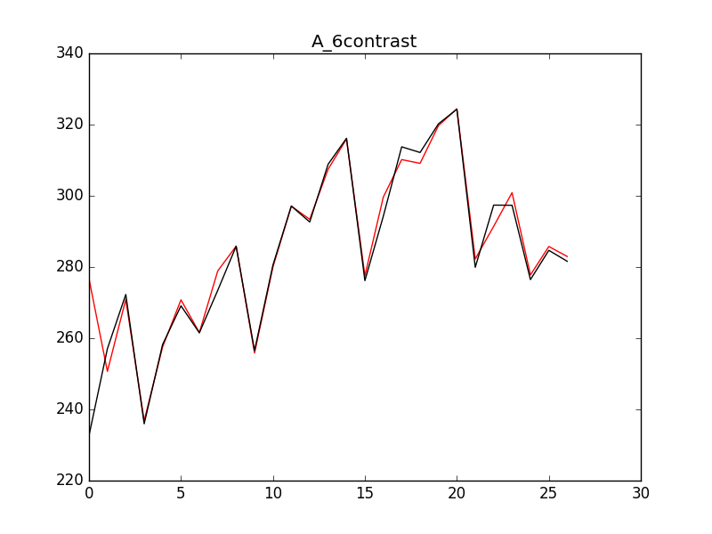

红色为预测值，黑色为实际值。

图中数值：

201403: 276.710672626 232.64450185

201404: 250.678649739 257.046724216

201405: 270.895559332 272.28342371

201406: 236.812696697 235.959388234

201407: 257.525190018 258.207057849

201408: 270.774089508 269.101446675

201409: 261.563809202 261.521651978

201410: 278.900226427 273.446645677

201411: 285.860289331 285.844660676

201412: 255.852392314 256.483017473

201501: 280.010853404 280.535741222

201502: 297.090716057 297.125552101

201503: 293.393175605 292.642789108

201504: 307.475871903 308.863964526

201505: 315.959554014 316.150934746

201506: 277.536282634 276.170014415

201507: 299.619480076 294.244397834

201508: 310.170470875 313.75617244

201509: 309.118799192 312.164223568

201510: 319.72055439 320.216716155

201511: 324.440745482 324.318952813

201512: 282.267564345 279.918411946

201601: 291.413935499 297.387040044

201602: 300.879137051 297.338653353

201603: 277.770586497 276.461195778

201604: 285.758824034 284.684699341

201605: 282.954930638 281.602107366

预测未来4个月：

238.065090303

245.953276712

249.07865065

208.014861782

一年为周期：

拟合效果图：

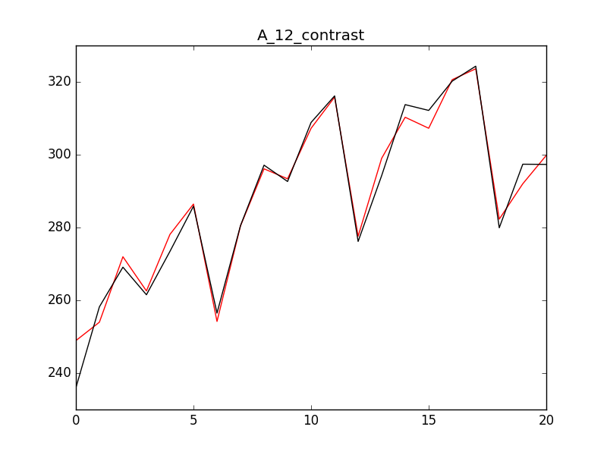

红色为拟合，黑色为实际值。

具体数据：

201406: 248.921375069 235.959388234

201407: 253.987521395 258.207057849

201408: 271.966914327 269.101446675

201409: 262.576497711 261.521651978

201410: 278.105536423 273.446645677

201411: 286.437249801 285.844660676

201412: 254.194065811 256.483017473

201501: 280.470487511 280.535741222

201502: 296.121463468 297.125552101

201503: 293.381733349 292.642789108

201504: 307.258125603 308.863964526

201505: 315.816298732 316.150934746

201506: 277.595559249 276.170014415

201507: 299.007419015 294.244397834

201508: 310.288048446 313.75617244

201509: 307.267260494 312.164223568

201510: 320.61297446 320.216716155

201511: 323.601451519 324.318952813

201512: 282.301296887 279.918411946

201601: 292.011572532 297.387040044

201602: 299.821802021 297.338653353

预测值：

247.175357424

256.242510801

260.247980745

219.749385837

半年为周期，训练时间201312-201511，预测201512-201606：

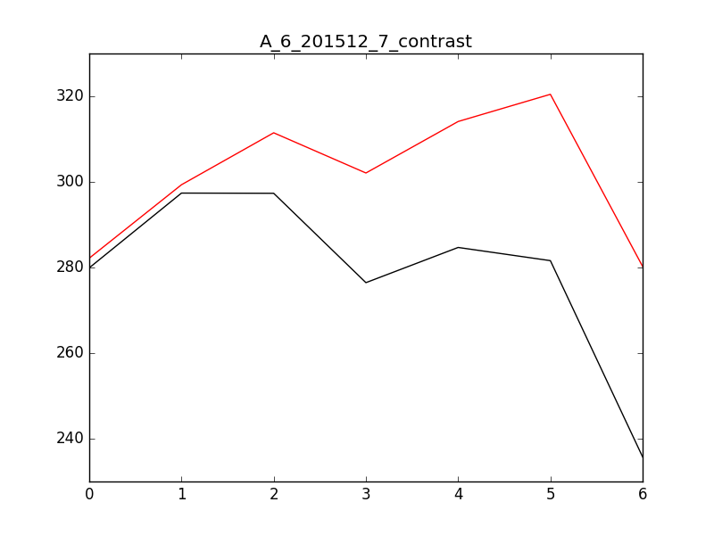

数据对比,左边预测值，右边真实值：

201512: 282.178598224 279.918411946

201601: 299.335510589 297.387040044

201602: 311.472706181 297.338653353

201603: 302.081931373 276.461195778

201604: 314.112610174 284.684699341

201605: 320.46529643 281.602107366

201606: 280.254148698 235.751433269

半年为周期，训练时间201312-201605，预测时间201606-201608

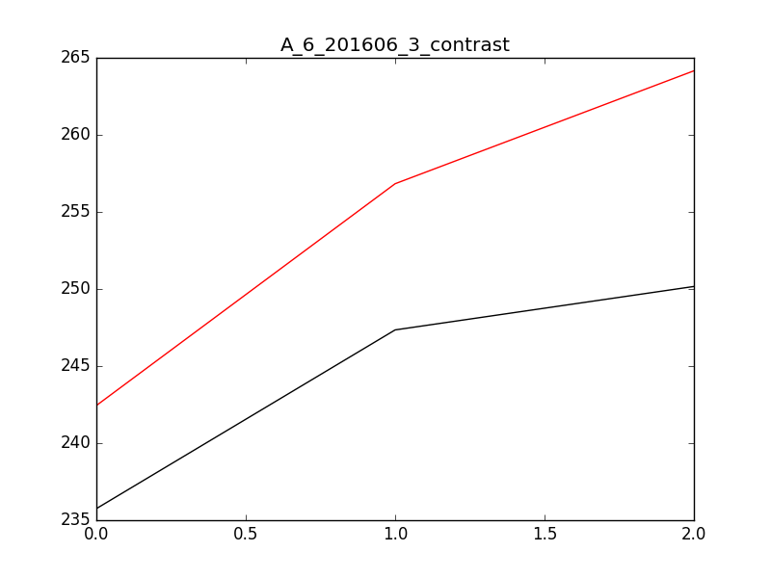

数据对比,左边预测值，右边真实值：

201606: 242.440693259 235.751433269

201607: 256.831056643 247.345597846

201608: 264.155508961 250.163619758

一年为周期，训练时间为201312-201605，预测时间201606-201608：

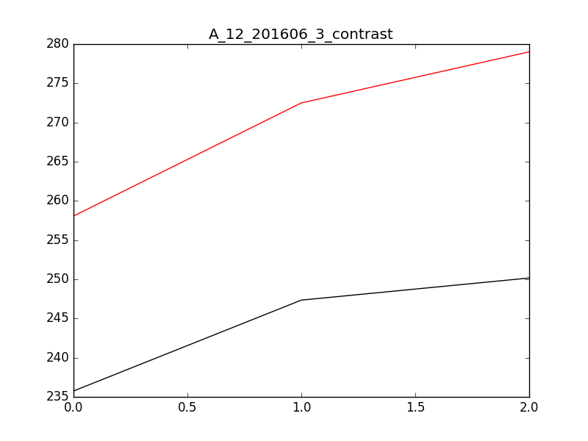

数据对比，左边为预测值，右边为实际值：

201606: 258.070590032 235.751433269

201607: 272.499554446 247.345597846

201608: 279.011705793 250.163619758

半年为周期，训练时间201312-201505，预测时间201506-201512

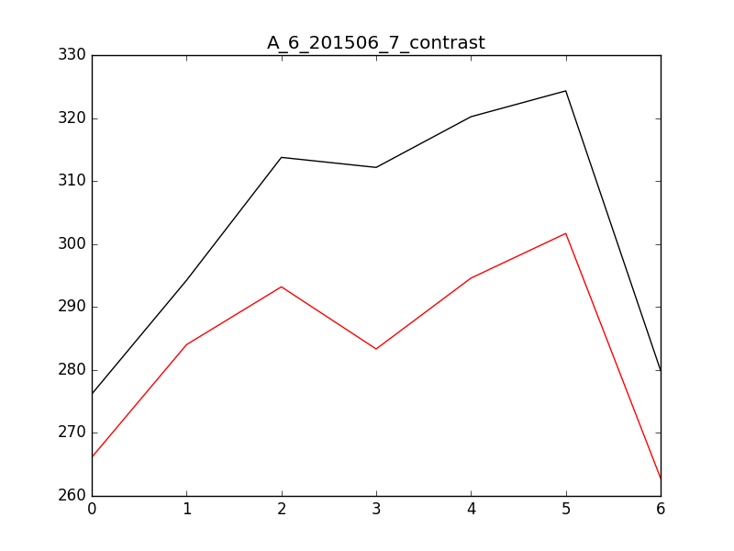

数据对比，左边为预测值，右边为实际值：

201506: 266.132641886 276.170014415

201507: 284.024107922 294.244397834

201508: 293.201673034 313.75617244

201509: 283.333488391 312.164223568

201510: 294.591971042 320.216716155

201511: 301.682065474 324.318952813

201512: 262.810500119 279.918411946